Shabbos Stories For
Parshas acharei mos-kedoshim 5785
Volume 16, Issue 32 12 Iyar 5785/May 10, 2025
Printed L’illuy nishmas Nechama bas R’ Noach, a”h
For a free subscription, please forward your request to keren18@juno.com
Past emails can be found on the website – ShabbosStories.com

The Sanzer Rov’s Payback
By Yehuda Z. Klitniick.

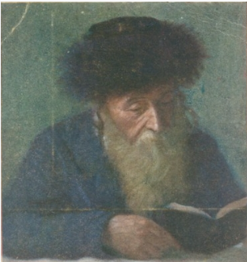
The Divrei Chaim (Sanzer Rov)

The great Gaon Reb Avrohom Yehuda HaCohen Schwartz of Beregszász in western Ukraine, the author of the sefer Kol Aryeh, often went to visit the Sanzer Rov, Harav Chaim Halberstam, the Divrei Chaim. The Kol Arye served as the Rav of Bergsaz, where he was appointed in 5621. Later, in 5641, he was appointed as
Rav in his birthplace and he moved to Mad.
He considered himself to be a talmid and a chossid of the Sanzer Rov. He traveled to the Sanzer Rov for Shavuos 26 times. And each time he was there for Shavuos the Sanzer Rov called him up to the Torah for Kohen. He was most often referred to as the Kol Aryeh, since that was the name of his most famous sefer.
One day, the Sanzer Rov needed a large amount of money for pidyan shvuyim, to redeem an innocent Jewish prisoner. So, he sent a telegram to Bergsaz to the Kol Aryeh. In the telegram he asked Reb Yehuda to raise a big sum of money for the cause. The Kol Aryeh went out by himself to the city, which had many wealthy Jews, andraised the needed sum of money, and sent it to Sanz.
The Sanzer Rov thanked the Kol Aryeh very gratefully, and wrote him a letter full of appreciation and praise. He also wrote, “Whenever you will need a yeshuah, this mitzvah will be useful to you.”
A few weeks later, RebAvrohom Yehuda became very sick. He was so ill, that they had to take him to Vienna to the big hospital there. Reb Avrohom Yehuda immediately asked them to send a telegram to Sanz to remind the Rebbe of the guarantee he had given him.
When the Kol Aryeh arrived at the hospital, the doctors were very scared. He had a hemorrhage, a sudden and significant loss of blood from a damaged artery, which is a medical emergency. Even today it is life-threatening. In those days, the best the doctors could do was very primitive, and usually didn’t help much. When he arrived at the hospital, it was the middle of the night. The leading
doctor of the hospital wasn’t there at the time, and the doctors that were there couldn’t decide how to operate.
Suddenly, they heard a loud commotion outside. Large horses were coming quickly to the hospital, pulling a wagon that held the head doctor. The head doctor
appeared at the door and briskly came in. It was strange, because the head doctor was never in the hospital at that time of night. The head doctor asked, “Where is the big Jewish Rabbiner from Bergsaz who traveled here from Hungary?”
Everyone in the hospital was astonished. How did the head doctor know about the arrival of the Kol Aryeh? There were no telephones in those days, so who could have told him? How did he know to come to the hospital at that time?
Meanwhile, the Kol Aryeh was lying in his sickbed, where the other doctors were standing and worrying about him. The head doctor rushed to his side, and did whatever he needed to do to save the patient. He gave a proper diagnosis and stopped the danger as it was happening. He gave instructions to the doctors and nurses about how to further treat this patient until he would be completely cured.
In a few days, the Kol Aryeh was completely healed. The head doctor came to visit him as Reb Avrohom Yehuda was getting better. The head doctor sat down by Reb Avrohom Yehuda’s bedside and told him the following:
“The night that you were brought here to the hospital, in extreme danger, I lay down to sleep, alone, in my bedroom. Suddenly, there appeared to me an old Yid who dragged his leg. (As is known, the Sanzer Rov was crippled in one leg. For that reason, he limped all his life.) He looked divine. He asked me to hurry and immediately go to the hospital, because they needed me very urgently.
“I thought it was just a dream, and I went back to sleep. But the man would not let me sleep. He shook me awake and said to me, ‘Honored physician! A big and important rov from Hungary, the Bergsaz Rov, is lying in your hospital. He is in a very deadly situation, and his life is in danger. The doctors cannot find a solution to his problem, and they desperately need you. Hurry now and run to the
hospital!’ He told me this several times, and wouldn’t leave me alone.
“So, I had no choice,” finished the head doctor. “I woke up my assistant. He took out my horses from the stable and hitched them to the wagon. As you can see, we came on time to the hospital. Everyone saw how the Sanzer Rov kept his guarantee, in the merit of what the Kol Aryeh did to help with a mitzvah. He passed away the 24th of Tishrei, 5644 and was buried in Mad. The Yahrzeit of the Sanzer Rov was 25 days of Nisson 5635, and was buried in Sanz.

Reprinted from the Parshas Bo 5785 email of Pardes Yehuda.

The Maharal’s Kallah

R’ Yehudah Loew ben Bezalel, known as the Maharal, was a young talmid chochom recognized for his brilliance and exceptional character. As his reputation grew, many prominent men sought him as a shidduch for their daughters, but the Maharal had his own criteria for a life partner. He valued truth, integrity, and dedication to Torah over wealth or social standing. He needed a wife who shared his commitment to Torah and was willing to forgo wealth and influence to support him in his principles.
The Maharal found such a partner in Perel, the daughter of R’ Shmuel ben Yaakov of Prague, a wealthy man. While some speculated that the Maharal was motivated by her fortune, he was truly interested in her character. However, just before their wedding, anti-Semitic riots broke out in Prague, leading to the expulsion of the Jews.
R’ Shmuel lost his fortune, and the engagement was called off, as he could no longer provide for the young couple. Despite the reversal of their fortunes, the Maharal remained steadfast. He told R’ Shmuel that Perel was his bashert, and he would wait for her. Perel, who had been raised in wealth and luxury, now found herself supporting her parents by selling baked goods. Though she faced hardship, she refused to marry until her family was in a better financial situation.
Meanwhile, the Maharal, now gaining renown as a talmid chochom, continued to turn down other offers, certain that his future lay with Perel. One day, while Perel was selling bread, a soldier rode by, pierced one of her loaves of bread and took it without paying. He was returning from the battlefront and hadn’t eaten for two days. But he promised to return and settle the debt.

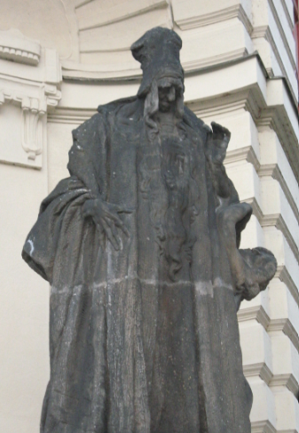
Ladislav Saloun’s Statue of the Maharal
at the New City Hall of Prague

Days later, he returned, handing her a colorful scarf as collateral. When Perel later prepared to sell the scarf, she discovered it was lined with pure gold, providing her family with the means to restore their wealth. This miracle enabled R’ Shmuel to recover his fortune, and the marriage between the Maharal and Perel was finally able to take place.
Thirteen years after their initial engagement, the couple married. The Maharal and Perel went on to have six children and many descendants, including some of the most prominent families of talmidei chachomim over the next few centuries.

I apologize for having accidentally deleted the source from where I found this story.
It Once Happened
Yehoshua’s Mother
Story #1
The young woman rose early. She hurriedly dressed in the half-light, making her way down the hill. Her attention was taken up by thoughts of the future. Following the sound of melodious voices, she arrived at the House of Prayer, and took up her usual position outside. It was here she came every morning, to sit upon the large rock and allow the sounds to enter her and fill her soul.
From the moment she knew there was life within her, her plan was clear. She would go every day to the House of Prayer and then to all the Houses of Study. Her child, though yet to be born, would gradually come to know the sounds of the holy words of Torah.
When asked where she was going, she would reply, "I am going to the House of Prayer, so that my baby can hear the holy words." No one could fathom her design; but to her it was perfectly clear.
On this particular cold, winter day, she sat immersed in her own prayer to the One Above to bless her child with wisdom and the ability to toil in His Torah. She sat until the scholars emerged. Shyly, she approached the first: "Please, bless my child with wisdom." The old man smiled at the young woman whose presence no longer surprised him. "May your child shine with the light of Torah," he replied. She then continued on to the various Houses of Study where she would sit beneath the open windows, the words of Torah permeating her essence.
The months passed. The young woman still made her early morning rounds, but now she was accompanied by her new son, her precious treasure.
She still visited both the Houses of Prayer and the Houses of Study, but now she propped up the small baby in his cradle which she carried from home. And from the early morning until the heat of the day had passed, the tiny baby sat, dozed, ate, and dozed again while the sacred melodies of Torah learning filled the air, enveloping him and filtering into his consciousness. The young mother was joyful with her lot and confident in the future of her small child, Yehoshua.

Story #2
Rabbi Yehoshua was tired. The road to Rome was long and difficult. But, thank G-d, his mission had met with success. His nerve-wracking debates with the vicious Hadrian had yielded the hoped for result - the severe decrees against the Jews had been rescinded. He could return to Yavne in peace, with good news for all his fellow Jews. Rabbi Yehoshua was enjoying his repose. Rabbi Yehoshua's thoughts turned to home. He longed to return to the Holy Land, to resume learning Torah with his beloved comrades, to enjoy the serenity of life's routines.
He was immersed in reverie when he was jolted by the appearance of a young Roman woman who stood before him with a saucy look on her face.
"So, you are Rabbi Yehoshua ben Chanania," she said with disdain.
"So, I am," answered Rabbi Yehoshua, for even in his humility he was aware that his fame extended to Rome. His wisdom, though, was equalled by his penetrating insight and deep-felt love for his fellowman.
"I have heard many tales recounting your wisdom," she replied. "But never would I have imagined that G-d would pick such an ugly vessel for his wisdom!"
Rabbi Yehoshua smiled at the girl's rude, but honest description of his appearance. He thought for only a moment and looked her in the eye, "Tell me, does your father have much old wine?"
"Yes, of course. We have quite extensive cellars," the girl answered.
"Well," he continued, "how does your father store the wine?"
"In clay jugs, of course."
"Can he not afford silver casks?" asked Rabbi Yehoshua, feigning surprise.
"Certainly, he could, but everyone knows that wine will spoil if it is stored in silver. Clay is the proper material for preserving wine."
"Ah, now you have your answer! The Creator of the World knows the proper receptacle for His wisdom, and thus has He created me! So, if you have some complaint, you must take it to my Creator!"
The Roman woman was both embarrassed and impressed by Rabbi Yehoshua's discourse with her. She quickly took her leave, murmuring apologies, but as for Rabbi Yehoshua, he was unperturbed by the whole encounter.
Back in Yavne, Rabbi Yehoshua felt an immense relief. Now, life's rhythms could begin anew; and to him life was synonymous with Torah. And for his great learning and his loving nature, he was loved by all whom he touched. The years accumulated greatness and honor, but Rabbi Yehoshua's aim never changed.
One day, already an old man, Rabbi Yehoshua sat with his students exploring a question in Jewish law. Was it incumbent upon the parents to bring their small children to hear the reading of the Torah during the Hakhel year? Rabbi Yehoshua listened to the discussion, and then related the story of how his mother would rise before dawn to sit beneath the open windows and allow her child to absorb the feel and essence of the holy words. All his life, Rabbi Yehoshua continued, he recalled his mother with blessing, for it was she who instilled in him the holiness to which his soul became attached.
Rabbi Yehoshua's comment sealed the Jewish legal conclusion with his own beautiful truth.

Reprinted from the archives of L’Chaim – 5762/2003 edition of Tazria-Metzora.
An Eternal Chesed Connection
By Rabbi Nachman Seltzer

Consider the following story, which I heard from a rav in England. As the rav of a shul, part of my job means comforting those who need comforting, visiting those who need visiting, and eulogizing those who need to be eulogized. It was Rosh Chodesh Elul when I went to visit a member of my shul who was very ill, and who’d requested urgently that I come to speak with him.
“Rabbi,” Brian said as we sat together, “I have a question to ask you. This is just between us. My wife doesn’t have to know we discussed it. Such talk would only cause her pain… My doctors tell me I am going to meet my Maker in six to eight weeks. What do I need to do to prepare myself?”
Brian’s question was shockingly authentic. I was at a loss. What does one say to a person asking you how they should prepare themselves for their imminent journey to the Next World?
“That’s a hard question, Brian,” I said to him, “and I will get back to you with an answer.”
I discussed Brian’s question with a few rabbanim and others, and got back to Brian with an answer — which will remain between me and him, because the answer to his question would be different for every person. As we sat together sharing a profound conversation, Brian said, “You know, Rabbi, sometimes a person reflects on their lifetime and certain stories come to mind. Would you like to hear one of the stories I’ve been thinking about?”
Of course I did.
“My wife and I had a daughter,” Brian began, “who passed away when she was almost nineteen years old. This didn’t come as a complete surprise, since she’d been unwell since she was born and her illness accompanied her throughout her life, which ended just prior to her nineteenth birthday.
“A few months after my daughter was born, we needed to take her to the hospital for a major operation. The hospital was located in Southwest London and I called the rav of our shul, to ask where I could daven on the day of the operation. I wanted a shul with a minyan for Shacharis.
“Rabbi Ginsburg soon called me back and said, ‘Go to Hendon Adass. The name of the rabbi there is Rav Pinchus Roberts. I’ve already spoken with him about you.’
“Hendon Adass was not at all close to the hospital. I took a taxi there, leaving sufficient time to deal with London traffic. On my arrival at the shul, Rabbi Roberts warmly welcomed me in and showed me where to sit. After davening, I was about to leave when the rav made an announcement about my daughter.

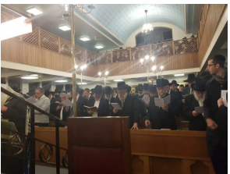
Congregants at London’s Hendon Adass Synagogue

“‘Rabbosai,’ he said, ‘we are now going to say Tehillim for a sick little girl who is about to undergo an operation.’ “There were over a hundred people in the shul at the time and every one of them stayed where they were and participated in the Tehillim. I was overcome by the fact that so many people were willing to drop everything and daven so fervently for my daughter. I’d never experienced anything like it in my life and was touched to my core.
“I made the return journey to the hospital, filled with hope and new strength from my experience at the shul. My daughter was wheeled into the operating theater, while my wife and I waited.
“Suddenly, there was a knock on the door. Opening it, I found a woman I’d never seen before in my life.
“‘Can I help you?’ I asked.
“‘I’m Rebbetzin Roberts,’ she said. ‘You were in my husband’s shul this morning for Shacharis. It is Erev Shabbos, and I’ve just taken a bus from Hendon to come and see you here at the hospital.’
“‘How long did it take you to get here?’
“‘An hour and a half.’
“We were very touched.
“‘The reason I came is because I brought you food for now, and for Shabbos.’ “Once again, we were touched beyond words. “‘We are going to sit down together,’ she said, ‘and you will eat some of the food I brought.’
“She insisted on joining us at one of the tables and watching as my wife and I partook of her delicious food. The Rebbetzin knew that if she left without ‘forcing’ us to eat something, we might never get around to eating. So, she sat us down, and only returned home once she was sure we had eaten. You can imagine how extremely grateful we were to her for making such efforts for two people she didn’t even know!
“Rabbi,” Brian said to me when he finished telling his story, “it’s been many years since Rebbetzin Roberts came to visit us in the hospital, but I remember it like yesterday. I never forgot how she was willing to travel to visit a couple she had never met with a package of food all the way from Hendon on an Erev Shabbos.”
This story occurred before so many Jewish organizations were established to care for patients and their families in the hospital for Shabbos. Back then, Brian and his wife were all alone in Southwest London without hope of visitors or hot Shabbos food. No wonder they never forgot the Reb betzin’s heartfelt action, though the story had taken place decades earlier!
Rabbi and Rebbetzin Roberts had since relocated closer to our community, and now, thirty-four years later, I thought about arranging a reunion between Brian and his wife and the Rebbetzin. Brian still remembered the episode with such clarity — and out of everything that had happened to him in his life, this was the story he’d chosen to share with me. In the end, however, the meeting didn’t happen. Brian was niftar on Erev Hoshana Rabbah.
I made the arrangements and attended his levayah. Just after the funeral ended, my phone rang with the news of a second levayah that I needed to attend. Rebbetzin Roberts had just passed away and was being laid to rest right then. This meant that I went directly from Brian’s levayah to Rebbetzin Roberts’.
I later learned that both taharah processes had been performed at the same time. When I came home that afternoon, I told my wife, “It’s amazing — they shared a story thirty-four years ago and now both went through the taharah process at the same time. What’s the lesson here? What am I supposed to take from this story?”
My wife thought about it, and then shared her insight with me. “I think this story teaches us that when you do a chesed for another human being, you become connected to that person in this world and the next, for all eternity. If you help another Yid for no other reason than because you love them for being a Jew, the two of you are bound together for all time. And the more chesed you do, the more connected you become to more and more members of Klal Yisrael — until you have formed an incredibly beautiful network of people who are all connected to one another. A chesed web of individuals who share something unique. Something that came about through the wonderful mitzvah of doing kindness for others.”

Reprinted from the Pesach 5785 edition of At the ArtScroll Shabbos Table. Excerpted from the ArtScroll book “Haggadah with Stories” by Rabbi Nachman Seltzer.
One Small Step
By Rabbi Paysach J. Krohn

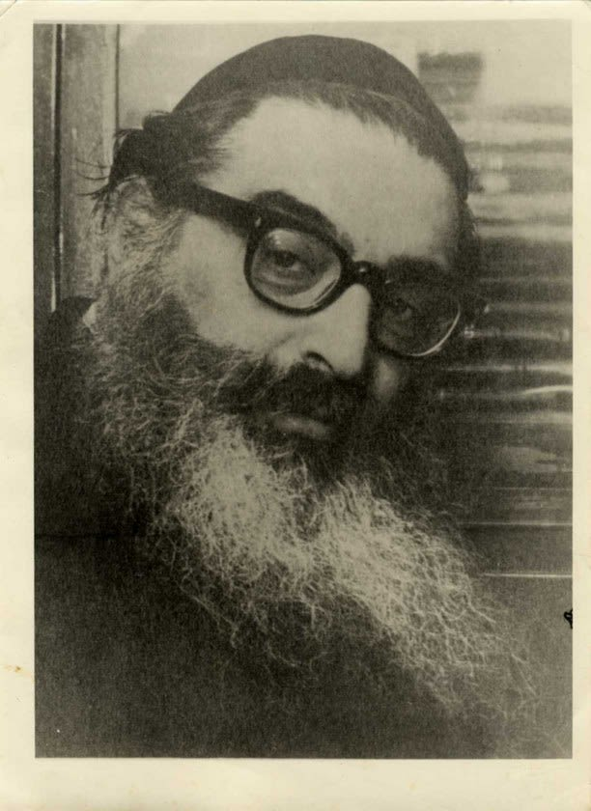
Rabbi Yitzchak Hutner

In May of 1973 Rabbi Yitzchak Hutner had to travel from Brooklyn to the Bronx to attend the berit milah of a son of one of his students. Rabbi Shimon Goldstein, who was then learning in the Bet Midrash of Yeshivah Rabbi Chaim Berlin, arranged for a taxi to take the Rosh Yeshivah, and together they traveled to the berit milah.
When both Rabbi Hutner and Rabbi Goldstein noticed the driver’s identity plate which had his name, Sol Yanofsky, in bold letters, they understood that he was Jewish. Meanwhile, in the front seat, the cab driver realized that one of his passengers was a prominent Rabbi. Without saying a word, he reached over to the right, picked up a cap and, as an act of respect, covered his bare head.
Rabbi Hutner turned to R’ Shimon and said to him in Hebrew so that the driver would not understand, “Who knows how much Olam Haba (merit in the World to Come) he will get for this act.”
R’ Shimon was surprised by the Rosh Yeshivah’s comment, for he didn’t think that putting on a cap in the presence of the Rosh Yeshivah was an act of such great significance. “Does it merit Olam Haba?” R’ Shimon asked.
“Let me tell you a story,” the Rosh Yeshivah replied. “The Hidushei Harim, Rabbi Yitzchak Mayer Alter, used to got to the mikveh every day. However, he never took the shortest route to the mikveh. Instead, every day he would take a long, roundabout way to reach his destination. For a while his attendant did not inquire about it until finally one day he became so curious that he did indeed ask the Rebbe why he purposely seemed to go the long way to get to the mikveh.
“‘I’ll tell you, said the Hidushei Harim. ‘When we go this way, we pass the station where Jewish porters unload the heavy packages for travelers. These porters are very simple, non-religious people. They do not pray, nor do they learn Torah. However, when they see me, they stop what they are doing, straighten up and call to each other, “Reb Itcha Myer is coming! The Rebbe, Reb Itcha Myer is coming!”
“‘As I pass by, they nod their heads respectfully and acknowledge my presence. For this (their display of kabod Hatorah) they will get Olam Haba. I know they have no other way of earning it, so I walk this way every day to give them that opportunity.’”
We must not underestimate the small acts we do, nor the seemingly simple acts that others do. But aside from that, is not the Hidushei Harim’s love of fellow Jews remarkable in that he gave Jews (even non-observant ones) the opportunity to gain Olam Haba? (Excerpted from the ArtScroll book – “In the Footsteps of the Maggid”)

Reprinted from the Parshas Shemini 5785 email of Rabbi David Bibi’s Shabbat Shalom from Cyberspace.

The Man in the Photo with Rav Moshe Feinstein
By Yoni Schwartz

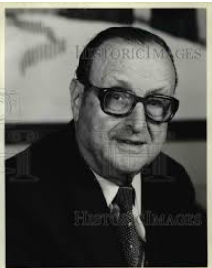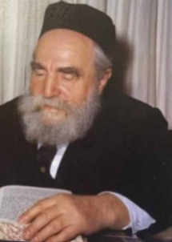
Irving Stone and Rav Moshe Feinstein

As Rabbi Joey Haber visited a school in Cleveland, he walked into the office of the head of the school, Rabbi Dessler, the grandson of Rav Eliyahu Dessler, ZT”L. As he was waiting, he noticed a strange picture - some businessman with Rav Moshe Feinstein, ZT”L. Normally, if a person has a picture of a gadol, it’s either just the gadol or a picture of himself with him, not some random person.
When Rabbi Dessler returned, Rabbi Haber inquired about the picture and was told the following story: “My father,” said Rabbi Dessler, “had a stroke about fifty years ago. That businessman is Mr. Irving Stone, the person whose name is on the blue Artscroll Chumash. He and my father were very close. So, when my father was very sick and in critical condition, Mr. Stone flew out to get a bracha from Rav Moshe Feinstein. That is a picture of him getting a bracha from Rav Moshe for my father. However, that’s not the end of the story.”
“About six months later, on Erev Rosh Hashanah, my father got a call: ‘Hello, this is Moshe Feinstein. I’ve been praying for you every day since your stroke. I want to know how you’re feeling and that you’re doing okay.’” Despite being one of the world’s busiest men, on one of the year’s busiest days - Erev Rosh Hashanah - Rav Moshe still made the time to check up on another Jew in need.

Reprinted from the Parshas Shemini 5785 email of Torah Sweets.
Raincoats and Umbrellas on a Sunny Dry Day in Tiberias
From the Desk of Yerachmiel Tilles

Rabbi Nachman of Horodenka arrived in Eretz Yisrael in 1764, during a difficult year of drought. The Turkish ruler of the city of Tiverya (Tiberias), who was always scheming against the Jewish residents, issued an appalling declaration. If rain did not fall within three days of his decree, he would expel every last Jew from his city.
R' Nachman did not panic. He assured those close to him that, in G-d's goodness, they were going to have the opportunity to sanctify His Name. According to the account written in Tabor Ha'aretz by the Chief Rabbi of Tiberias, R' Moshe Klieres, R' Nachman ordered his fellow Jews to go to the cave where R' Chiya and his sons were buried and to pray there for rain.
He went with them. Though the day was sunny and dry, he advised them to bring along rain gear. The left the city and made their way to the cave, protective clothing slung over their arms and some with umbrellas in their hands. A government official caught a glimpse of them at the city gates, and laughed heartily at the raincoats the Jews carried. Spitting in their faces, he declared that if they returned to the city without rain having fallen, he would grind the Rabbi beneath his heels. The Jews, led by R' Nachman, did not answer him, but continued quietly to the cave of R' Chiya and his sons. There, they poured out their hearts in prayer.
G-d heard them. Dark clouds filled the sky, and then a heavy rain began to fall -- so heavy that, had the men not carried rain gear, they would not have been able to return to town at all that day. Upon their return to Tiberias, the government official was waiting for them at the city gates. He placed R' Nachman on his shoulders and carried him into the heart of the city, where the people were overcome with joy at the blessed rains that were falling at last.
G-d's great Name was sanctified, with Jews and non-Jews together proclaiming, "Who is like You among the gods, and who is like Your people, Israel?" This episode raised the Jews' esteem greatly in the eyes of the populace, and when, some twelve years later, a large influx of Jews arrived in Tiberias under the leadership of R' Menachem Mendel of Vitebsk, author of Pri Ha'aretz, and R' Avraham of Kalisk, they were received with the greatest respect and welcomed with open arms.

Source: Adapted and supplemented by Yrachmiel Tilles from "Stories My Grandfather Told Me" by Zev Greenwald] Reprinted from the Parshat Pekudei 5785 email of KabbalaOnline.org, a project of Ascent of Safed in Israel.

The Diligent Learner of Torah
Rav Gamliel Rabinowitz shared a story that someone had told him, which this man had witnessed:
Right before Pesach, a tall man came into our Kollel. In one hand he carried a briefcase, and in the other, he held a binder. My curiosity was aroused, and I followed him to see what he was there for. He sat down on a bench by the wall, and he opened the briefcase, which was filled with crisp new bills.
At his request, the young men in the Kollel began to go over to him, and one after the other, he would write down the name of the young man, and hand him a new 200 Shekel bill, to be used for his Pesach expenses. I also approached him and received a gift. I was very happy to get this monetary help, and I thanked him warmly.
I waited until after all the distributions, and I noticed a young man sitting in another corner of the Beis Medrash, and he had not lifted his eyes from the Sefer he was learning the whole time. I felt bad for him to lose out on the money because he was learning, and I went over to him and told him that the man was almost finished handing out money to everyone, but he simply replied, “When one is learning, he does not stop for any treasure in the world!”
He then went back to his Sefer, and didn’t pay attention to anything else that was going on. I was amazed by his devotion, and even more awed by his strength, knowing that he did not have a penny is his pocket. Still, he continued learning as if nothing was happening around him. I waited until after the distribution, when every young man had taken his Yom Tov gift and had continued learning.
When the wealthy man finished, he noticed that young man sitting on the other side of the Beis Medrash, and he asked me who that young man was, and why he hadn’t come over to get his Pesach gift? It was remarkable to me, because presently, there were about 180 young men learning in the Kollel, and he noticed one person who didn’t approach him for a gift. I told him that this certain individual will not stop learning for anything.
The man finished, closed up his briefcase, and headed right over to that young man who was still learning. I saw him put 1,000 Shekel into the hand of the young man, and wished him a Chag Samei’ach. The young man smiled and thanked him with sincerity, and immediately continued learning as if nothing had happened. The wealthy man then left the Beis Medrash.
When I watched this happen, I got an incredible lesson of what it means to live a life of Emunah and trust in Hashem. This story took place years ago, but it left an everlasting impression on me. I learned what Chazal have taught, that there is no one who listens and does the will of Hashem and loses out because of it!

Reprinted from the Parshas Shemini 5785 email of Rabbi Yehuda Winzelberg’s Torah U’Tefilah.

